CSCM37: Data Visualisation

Assignment 1

Andrew Gray

445348

Part 1 - A Real-World Challange

Design 1

**Image:** The visualization itself as an image

**Visual Design Type:** Gantt

**Name of Tool:** Tableua Desktop

**Country:** All countries are shown.

**Year:** Between the years 1896 and 2018

**Visual Mappings:** Each of the visual design mappings. Include the data mapping information about color, shape, size, position (x,y axes), and any other visual mappings.

The x coordinates are made up of the year that the power plant was commissioned, and the y coordinates are made up of the primary fuels of the commissioned power plants.

**Unique Observation:** Things we can learn from the visualization, e.g, from this visualization we can see this pattern. . .

The oldest powerplant was commissioned in the USA in 1896 and its main fuel type was hydo. The second commissioned powerplant was also in the USA and again this was hydo which was commissioned in the 1899. Then in 1900 3 power plants were commissioned. Brasi

**Data Preparation:** There was no modifications made to this

A good observation requires interpretation of the resulting image that you generate.

Design 2

**Image:** The visualization itself as an image

**Visual Design Type:**  Map

**Name of Tool:** Tableua Desktop

**Country:** France, Germany, Great Britain, Russia, China, Japan, South Korea, USA, Canada, Brazil.

**Year:** Estimation for 2018.

**Visual Mappings:** X and Y axis use the longitude and latitude values, this produces the map.

Two filters have been applied, primary fuel, which is set to solar and country, which just shows the top 10 based on the sum of the estimated generation of energy.

Country is used to label the visualisation as well as the text. Colour is used to give a scale of the values, with dark being the biggest and a lighter colour being the smallest.

**Unique Observation:**  Germany is estimated to have the highest amount of solar energy created in 2018, at a value of 36,056. China is the second biggest estimation of solar power generated.

Weirdly enough, most counties around the equator are not in the top 10 of solar power energy generated. You would think that this would be an effective source to tap into.

**Data Preparation:** None.

Design 3

**Image:**   
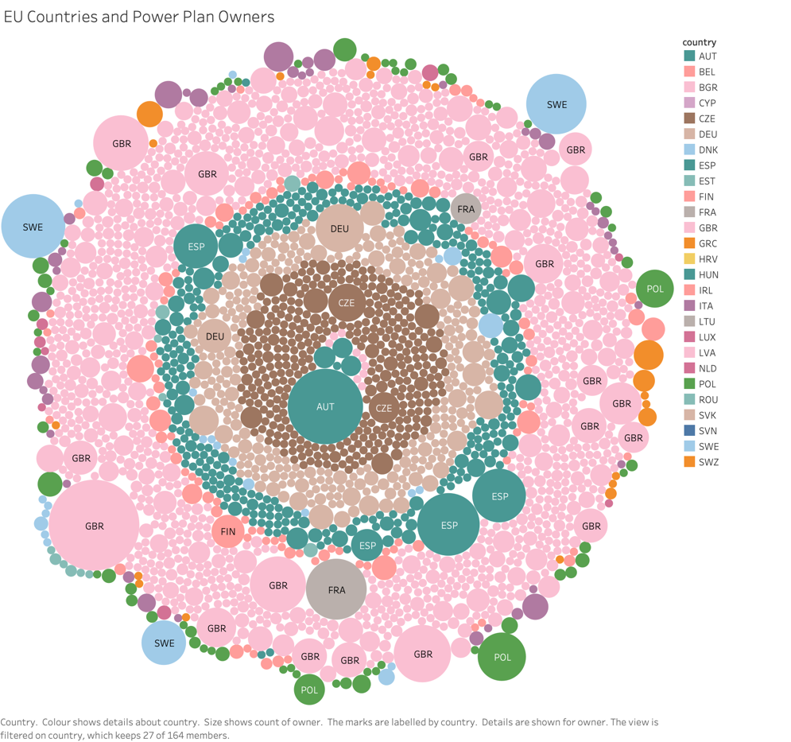

**Visual Design Type:** Packed Bubbles

**Name of Tool:** Tableau

**Country:** EU members including the UK.  Austria, Belgium, Bulgaria, Cyprus, Czech Republic, Germany, Denmark, Estonia, Spain, Finland, France, United Kingdom, Greece, Croatia, Hungary, Ireland, Italy, Lithuania, Luxembourg, Latvia, Malta, Netherlands, Poland, Portugal, Romania, Sweden, Slovenia, Slovakia.

**Year:** Up to current point.

**Visual Mappings:** The count of the owner was used to generate the size of the bubbles. The owner was also used as a detail as well as the sum of the number of records on the visualisation. Country was used for the colour coding and also used for the tooltip.

**Unique Observation:** All of France’spower plants are owned by two companies, EDF and GDF-Suez. While the Great Britton has the most amount of different owners for their power plants.

**Data Preparation:** No alterations.

Design 4

**Image:**

**Visual Design Type:** Treemap

**Name of Tool:** Tableau

**Country:** GBR, ESP, DEU, ITA, FRA, GRC, DNK, IRL

**Year:** 2018

**Visual Mappings:**

**Unique Observation:** Things we can learn from the visualization, e.g, from this visualization we can see this pattern. . .

**Data Preparation:** Any modifications to the original data that had to be performed to generate your beautiful image.

A good observation requires interpretation of the resulting image that you generate.

Design 5

**Image:**

**Visual Design Type:** Area Charts Continuous.

**Name of Tool:** Tableau

**Country:** USA

**Year:** 1890 - 2018

**Visual Mappings:**

**Unique Observation:**

**Data Preparation:** No alterations.

* Is this a task??

**What is better?**

**Part 2: More Depth**

**Image**: the treemap image you are describing  
• **Name of Tool**: The tool that was used to generate the treemap  
• **Country**: Name of country(s) data shown  
• **Year**: the year(s) or time-span of data shown  
• **Data Preparation**: A helpful description of how you prepared the data • **Color**: what is color mapped to?  
• **Hierarchy**: What is the data hierarchy contained in the treemap?  
• What leaf node size is mapped to?  
• How are the leaf nodes laid out or positioned?  
• What are internal nodes mapped to?  
• What is internal node size mapped to?  
• Which treemap node layout algorithm is used?

Some of these questions may require some research or extra background reading to answer. The data set used must contain at least 1,000 data records (rows). Also, you may not simply re-use a treemap from part 1. If you used a treemap in part 1, then create a different one for part 2.

**Part 3: Getting Professional Help**

VisGuides.org Username: AndyGray87

**Question Posted with citation of paper: Add screen shot**

**Question Response.**

**Q’s to ask.**

* Does my visual design make sense?  
  • Is my choice of color map optimal?  
  • How can my visual design be improved?
* Are there any other types of visual layouts that would be better for this challenge?
* How else could I visualize the relationships between countries?

1) your description,  
2) your image,  
3) your question and  
4) your Visuguides.org username.

References

Andrews, Keith, and Martin Lessacher. 2010. “Liquid Diagrams: Informa- tion Visualisation Gadgets.” *2010 14th International Conference Information*

*Visualisation*, 104–9. <https://doi.org/10.1109/IV.2010.100>. Geng, Zhao, Robert S. Laramee, Fernando Loizides, and George Buchanan. 2011.

“Visual Analysis of Document Triage Data.” In *Proceedings of the International Conference on Imaging Theory and Applications and International Conference on Information Visualization Theory and Applications*, 1:151–63. Algrave, Portugal. https://doi.org/10.5220/0003320401510163.

Ward, Matthew O., Georges Grinstein, and Daniel Keim. 2015. *Interactive Data Visualization: Foundations, Techniques, and Applications, Second Edition - 360 Degree Business*. 2nd ed. USA: A. K. Peters, Ltd.

remote: warning: File iOS Bootcamp/App Brewery Massive Bundle/PSD UI Designs/Funky Tunes/Free Sample.psd is 50.96 MB; this is larger than GitHub's recommended maximum file size of 50.00 MB

remote: **error: GH001: Large files detected. You may want to try Git Large File Storage -** [**https://git-lfs.github.com**](https://git-lfs.github.com)**.**

remote: **error: Trace: a69c919f8f7b5f5605c8db968db69ed4**

remote: **error: See** [**http://git.io/iEPt8g**](http://git.io/iEPt8g) **for more information.**

remote: **error: File iOS Bootcamp/iOS Zip Files Original/atom-mac.zip is 278.77 MB; this exceeds GitHub's file size limit of 100.00 MB**

remote: **error: File iOS Bootcamp/App-Brewery-Massive-Bundle.zip is 590.38 MB; this exceeds GitHub's file size limit of 100.00 MB**

To <https://github.com/codingWithAndy/Bootcamps.git>

! [remote rejected] master → master (pre-receive hook declined)